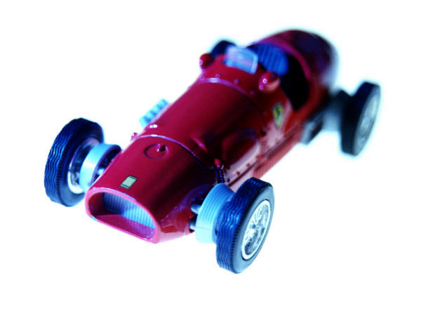5/24/2019

|  |
| --- |
| IoT Project | By: Keerthi Battini, E Rashmi Rathan & Achri Resha D Shira |

|  |  |
| --- | --- |
| Smart Bridge | Smart Connected Sign Boards for Improved Road Safety |

# INTRODUCTION:

IoT is an abbreviation for Internet of Things. The Internet of Things is an emerging topic of technical, social, and economic significance. It is basically the technical ability of the everyday objects to connect with one another through the internet connectivity and power data analytic capabilities.

## PREFACE

This application is created with an aim to provide an awareness to the users about the geographical conditions and features of the area, in order to enable safe driving on the road. The project proposes a system which has a digital sign board, that can be changed dynamically. The project is IoT based and uses Weather Api and other Internet enabling hardware devices, such as nodeMCU, basic shield,etc. in order to achieve the task.

ABOUT THE PROJECT

## DESCRIPTION:

In present systems, the road signs and the speed limits are static.But the road signs can be changed in some cases. We can consider some cases when there are some road diversions due to heavy traffic or due to accidents, thereby changing the road signs accordingly if they are digitalized.

Here, the project is an IoT based application that proposes the digitalized sign boards that predicts the necessary information to the user as per the respective area’s conditions.

The information sign boards can be entered through the web app accordingly. Three switches will be provided with different functionalities . The data is retrieved and displayed on the sign boards dynamically.

## HARDWARE COMONENTS:

## 1. NodeMCU

NodeMCU is an open source IoT platform. It includesfirmware w ich runs on the ESP8266 Wi-Fi SoC form Espressif Systems, and hardware which is based on the ESP-12 module.

MEMORY:128kB

DEVELOPER:ESP8266 Opensource Community

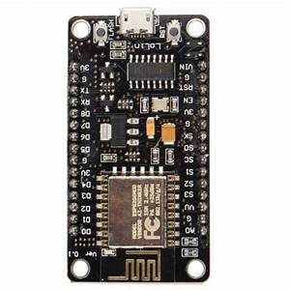

## 2.OLED

An OLED is an Organic Light Emitting Diode. The emissive electroluminescent layer is a film of organic compound that emits light in response to an electric current. In this project. it is used for displaying the information according to the data input.

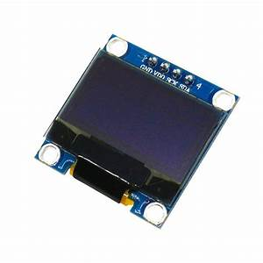

## 3.Basic Shield

Basic Shield is an I/O expansion board designed for use with microcontroller boards. It provides the simple digital input devices such as the switches and buttons, and digital output devices such as discrete LEDs and high current open FET drivers.

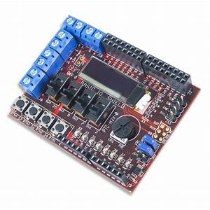

# HARDWARE COMONENTS:

## 1.IBM Cloud

IBM cloud computing is a set of cloud computing services from IBM that offers both platform as a service and infrastructure as a service.

## 2.NodeRed

Node-RED is a programming tool for wiring together hardware devices , APIs and online services in new and interesting ways.

## 3. MIT App Inventor

It is an open source web application for android, originally provided by Google. It enables the users to create new software for Android Applicstion System.

# FUNCTIONALITIES:

* Object prediction
* Weather prediction
* Stating the direction to avoid accidents
* Temperature display
* Humidity display
* Speed limit

# INSTALLATION:

1. CAR: Every Car can have a digital device attached to it that requires an internet connection in order to allow this service.
2. MOBILE APP: The easiest way of installing the app could be in the form of a mobile app.
3. DIGITAL SIGN BOARDS: In the ideal scenario, sign board itself could be installed in every interval of the most commonly taken route. The sign boards will be digitalized and any user can easily take a look at the information being displayed.

PROS AND CONS

This system can be, no doubt , of the most beneficial applications. It will be capable of saving thousands of lives from encountering accidents.

However. Installation and implementation could be a problem due to the following major reasons:

1. High cost, some might not be able to afford the additional feature in the cars making them more expensive.
2. Internet is not an anywhere-available-and-cheap service yet, in a country like ours.
3. Since the internet service is not fast enough, the information is very likely to delay in certain places.

# CONCLUSION:

Safety is something to always think about. With the help of technology such as IoT , many ideas can be woven; and this is just one of them.

If this idea can be implemented big, surely the people will obtain a huge convenient. We never know if the application as such becomes immensely handy in the near future. Nothing is certain